Schedule reliability continues on an upwards trend
Sea-Intelligence – Press Release (Aug 29th, 2022)
www.Sea-Intelligence.com

Sea-Intelligence has published issue 132 of the Global Liner Performance (GLP) report, with schedule reliability figures up to and including July 2022. As the report itself is quite comprehensive and covers schedule reliability across 34 different trade lanes and 60+ carriers, this press release will only cover the global highlights from the full report.
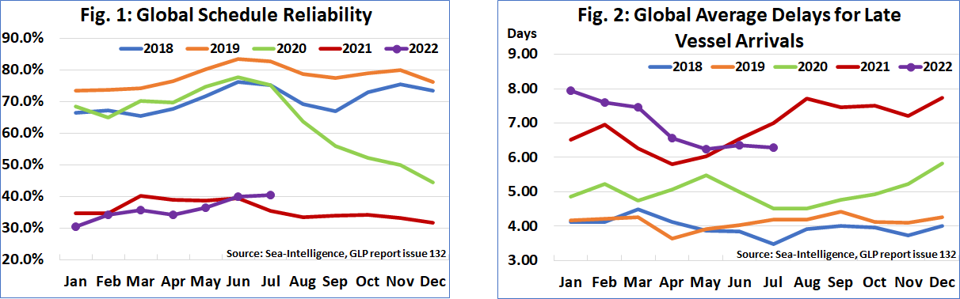
Global schedule reliability continues to trend upwards, increasing by 0.5 percentage points M/M in July 2022 to 40.5%. This is now the second time since the start of the pandemic that schedule reliability improved Y/Y. The average delay for LATE vessel arrivals have been dropping sharply so far this year, tapering off a little in the past few months. In July 2022, average delay improved by -0.09 days M/M, which means that the delay figure is now firmly below the 7-day mark, and an improvement over the respective 2021 figure.
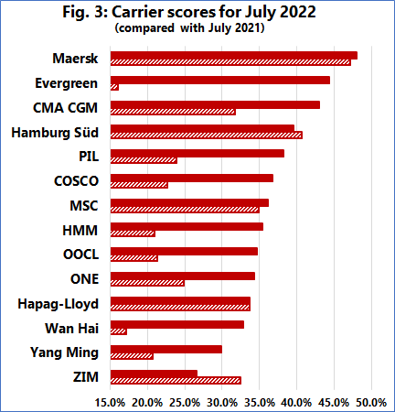
With schedule reliability of 48.0%, Maersk was the most reliable carrier in July 2022, followed by Evergreen with 44.3%. CMA CGM also recorded schedule reliability of over 40%. There were 9 carriers with schedule reliability of 30%-40% and only two with schedule reliability of 20%-30%. In July 2022, once again, a lot of the carriers were very close to each other in terms of schedule reliability, with 10 carriers within 10 percentage points of each other. ZIM had the lowest schedule reliability in July 2022 of 26.6%. On a Y/Y level, 11 of the top-14 carriers recorded an improvement in schedule reliability in July 2022, with 7 carriers recording double-digit improvements.
--- 000 --- END OF PRESS RELEASE --- 000 ---
All quotes can be attributed to: Alan Murphy, CEO, Sea-Intelligence.
For more information, please contact: ia@sea-intelligence.com, am@sea-intelligence.com

