Schedule reliability continues to be under 40% in 2021
Sea-Intelligence – Press Release (Dec 27th, 2021)
www.Sea-Intelligence.com

Sea-Intelligence has published issue 124 of the Global Liner Performance (GLP) report, with schedule reliability figures up to and including November 2021. As the report itself is quite comprehensive and covers schedule reliability across 34 different trade lanes and 60+ carriers, this press release will only cover the global highlights from the full report.
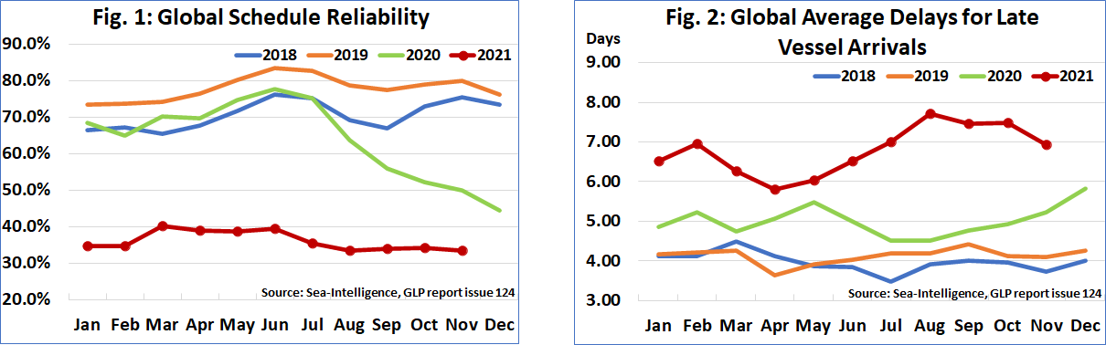
Schedule reliability declined M/M in November by -0.6 percentage points to 33.6%, maintaining the range of 33%-40% seen throughout the year. The only continuing “positive”, if one should call it that, is that schedule reliability has not plummeted further. On a Y/Y level, schedule reliability in November 2021 was down -16.4 percentage points. The average delay for late vessel arrivals on the other hand, dropped down to 6.93 days, albeit still the highest figure for this month, which has been a recurring theme in 2021.
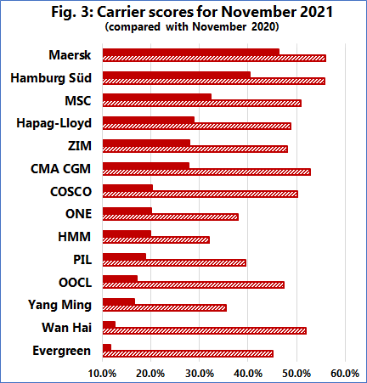
Maersk was once again the most reliable top-14 carrier in November 2021, with schedule reliability of 46.3%, followed by Hamburg Süd with 40.4%. Only MSC had schedule reliability between 30%-40%, with five carriers recording schedule reliability of 20%-30%. The remaining six carriers had schedule reliability of under 20%, with Evergreen recording the lowest November 2021 schedule reliability of just 11.8%. Four carriers recorded a M/M improvement in schedule reliability, while no carrier recorded a Y/Y improvement in schedule reliability, with all but Maersk recording double-digit Y/Y declines.
--- 000 --- END OF PRESS RELEASE --- 000 ---

All quotes can be attributed to: Alan Murphy, CEO, Sea-Intelligence.
For more information, please contact: ia@sea-intelligence.com, am@sea-intelligence.com

