Schedule reliability continues to be low in May 2021
Sea-Intelligence – Press Release (June 30th, 2021)
www.Sea-Intelligence.com

Sea-Intelligence has published issue 118 of the Global Liner Performance (GLP) report, with schedule reliability figures up to and including May 2021. As the report itself is quite comprehensive and covers schedule reliability across 34 different trades lanes and 60+ carriers, this press release will only cover the global highlights from the full report.
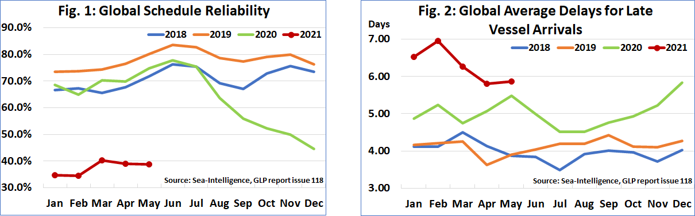
Schedule reliability has been largely consistent these past few months, albeit at a much lower level than the industry stakeholders would have preferred. In May 2021, schedule reliability declined by -0.2 percentage points M/M to 38.8%. On a Y/Y level, schedule reliability was down a massive -36.0 percentage points. The average delay for LATE vessel arrivals on the other hand had been improving since March 2021. In May 2021 however, the average delay increased slightly by 0.05 days to 5.86 days. The level of delays in 2021 have been the highest across each month when compared to the previous years.
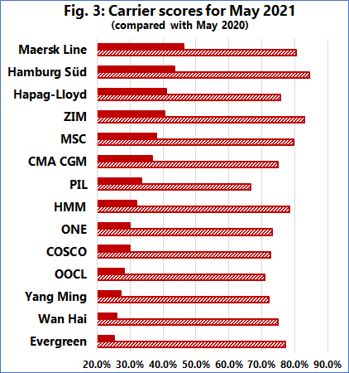
Maersk Line was the most reliable top-14 carrier in May 2021, with schedule reliability of 46.2%. Three more carriers had schedule reliability higher than 40%, with six carriers between 30%-40%, and four under 30%. Evergreen had the lowest schedule reliability in May 2021 of 25.1%. Six carriers recorded a M/M improvement in May 2021, although the largest improvement recorded by MSC was of just 2.3 percentage points. The largest M/M decrease was of -14.4 percentage points recorded by Wan Hai, the only carrier to record a double-digit M/M decline. None of the top-14 carriers recorded a Y/Y improvement in schedule reliability, with all carriers recording double-digit declines of over -33.0 percentage points.
--- 000 --- END OF PRESS RELEASE --- 000 ---
All quotes can be attributed to: Alan Murphy, CEO, Sea-Intelligence.
For more information, please contact: ia@sea-intelligence.com, am@sea-intelligence.com

