US goods consumption continues to grow
Sea-Intelligence – Press Release (Nov 9th, 2021)
www.Sea-Intelligence.com

In issue 539 of the Sunday Spotlight, we analysed the US consumption data for September 2021, released by the US Bureau of Economic Analysis (BEA).
Growth in personal consumption reversed back to pre-pandemic level in September 2021, however, when we look at a breakdown, we see that growth in consumption of goods is still fast outpacing that of services. Breaking it down further, we see a gradual increase in growth levels for nondurable goods. On the other hand, we see a spike in early 2021 followed by declining growth levels for durable goods, albeit to only a little under 10%.
We then continued to look at the subcategories to see the major demand drivers. One of the highest growing subcategories is Furniture, as shown in figure 1.
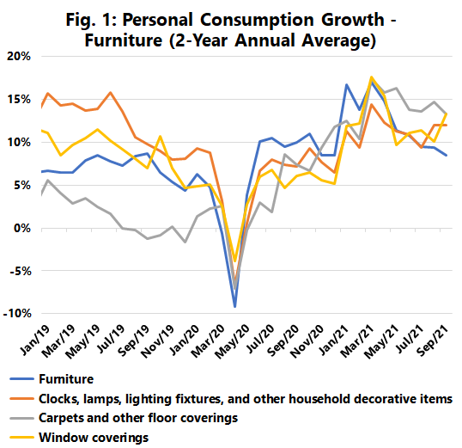
These components take up a significant portion of container volumes, and the continued high level of growth in all these categories is one of the major drivers of the continued boom in North American import volumes. The data does seem to indicate that the furniture component is a slightly leading indicator for the three other components, i.e. it appears the average consumer first procures new furniture and only thereafter, with a slight time delay, augments the new purchase with carpets, lamps, window coverings, etc. If this link continues going forward, it means that we should now begin to see growth rates for these other furniture components decline, as the furniture category itself has indeed seen a declining growth trend over 2021.
The consumption boom driving container volumes showed no signs of abating in September. Whilst there was some element of decline in the growth rate, this was to a large degree driven by motor vehicles and not by typically containerised consumer commodities. There is a trend of shifting from durable to non-durable goods though, but that does not materially alter the boom in container volumes either. This means we should not expect a decline in demand to “rescue” the congestion and bottleneck situation, in the short to medium term.
--- 000 --- END OF PRESS RELEASE --- 000 ---
All quotes can be attributed to: Alan Murphy, CEO, Sea-Intelligence.
For more information, please contact: ia@sea-intelligence.com, am@sea-intelligence.com

