Downward pressure on rates demand driven?
Sea-Intelligence – Press Release (July 5th, 2022)
www.Sea-Intelligence.com

Given the recent decrease in spot rates (below what could be explained by normal seasonality), in issue 571 of the Sunday Spotlight, we tried to answer a very pertinent question: is the downwards pressure of spot rates caused by supply or demand? As the demand data (as an example published by Container Trade Statistics) is notoriously time-lagged, we used our timely and forward-looking supply side data to see if there was an extraordinary spike in deployed capacity, which could offer an explanation to this decrease.
Figure 1 shows both the Y/Y capacity growth and the annualised capacity growth (versus 2019) for Asia-North America West Coast, while figure 2 shows the same for Asia-North Europe.
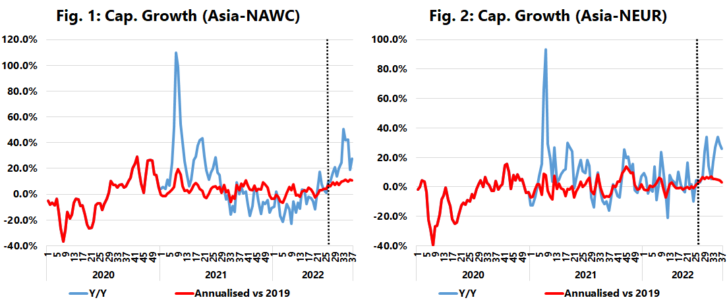
For Asia-North America West Coast, the developments are quite curious. Ballooning of capacity could have framed a case for dropping spot rates, but since the annualised growth has been under 5%, it seems as if the current downwards trend is informed by a decrease on the demand side. This in itself should be quite worrying for the carriers, especially as we are headed into the traditional peak season. This is possibly an indication that the market is not as strong as expected. Even on Asia-North Europe, both sets of capacity growth figures have been fluctuating around the 0% mark, indicating that the downwards pressure on spot rates is not supply driven and rather because the market is not as strong as initially expected for the 2022 peak season.
--- 000 --- END OF PRESS RELEASE --- 000 ---
All quotes can be attributed to: Alan Murphy, CEO, Sea-Intelligence.
For more information, please contact: ia@sea-intelligence.com, am@sea-intelligence.com

