Delays improving faster than 2015 USWC dispute
Sea-Intelligence – Press Release (Aug 31st, 2022)
www.Sea-Intelligence.com

In the second article of issue 579 of the Sunday Spotlight, we looked at the only historical precedent of vessel delays that comes even closer to the current market situation: the US West Coast port labour dispute of early 2015.
Methodologically, it is possible to analyse how quickly operational normality was reverted in 2015 and use this as a benchmark for how much time it will take to revert the ongoing crisis.
That said, issues in 2015 were related specifically to the ports on the US West Coast, were not global, and did not involve hinterland problems (all of which are present today). Therefore, we will get a minimum timeline for recovery, with the reality likely being longer.
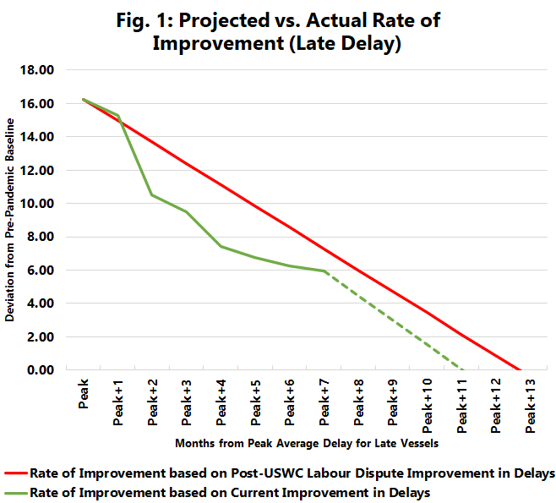
For average delays, the peak deviation during the US West Coast labour dispute was 8.92 days. Given that it took 7-8 months for delays to get back to the pre-dispute baseline (set as January 2012-July 2014), we can calculate the rate of improvement as 1.12-1.28 days per month. In comparison, the peak pandemic deviation was 16.25 days (when compared to the pre-pandemic baseline set as January 2017-December 2019).
Figure 1 shows two things. Firstly, if the rate of improvement from the peak pandemic delay is the same as it was post-2015 labour dispute, we would see a reversal to the pre-pandemic baseline in 13 months, which translates to January 2023 (shown by the red line). Secondly, if we, on the other hand, take the current average rate of improvement so far in 2022, average delay will revert to the pre-pandemic baseline in 11 months, which translates to November 2022 (shown by the green line). This means that the current rate of improvement is faster than a prediction based on the recovery after the US West Coast labour dispute.
--- 000 --- END OF PRESS RELEASE --- 000 ---
All quotes can be attributed to: Alan Murphy, CEO, Sea-Intelligence.
For more information, please contact: ia@sea-intelligence.com, am@sea-intelligence.com

