Utilisation drives rates down – except Atlantic
Sea-Intelligence – Press Release (Feb 23rd, 2023)
www.Sea-Intelligence.com

During the pandemic period, a combination of high demand coupled with a unprecedented loss of capacity from vessel congestion, led to vessel utilisation rates spiking to record levels, which in turn led to spike in spot rates, with both reaching a peak in February 2022. Since then however, vessel utilisation has dropped sharply; in the case of Transpacific, it is now back to the pre-pandemic levels, whereas in the case of Asia-Europe, it dropped below the pre-pandemic levels at first, but is now back to pre-pandemic levels.
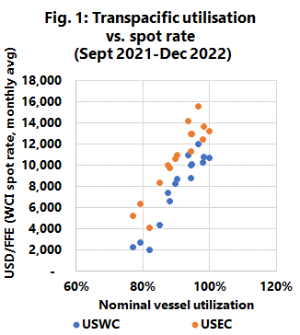
Interestingly, the dynamic between utilisation and spot rates varies depending on whether utilisation is increasing or decreasing. When utilisation was increasing on the Transpacific, spot rates remained relatively unchanged at a low level, until a trigger point of around 90% nominal vessel utilisation triggered a sharp increase in spot rates. When utilisation levels started to decrease since the peak in February 2022, we see a much more linear relationship between utilisation and spot rates, as illustrated in Figure 1 for the Transpacific trade. We see the same general pattern for Asia-Europe, although with a bit more noise. Overall, the rate developments in the Transpacific and Asia-Europe trades match expectations very well, if the assumption is a market operating with a close link between supply, demand, and pricing.
However, in the Transatlantic trade there is seemingly no clear correlation between utilisation and spot rate levels. Unlike the Transpacific and Asia-Europe trades, declining utilisation levels have thus far failed to have an impact on pricing in the trade, indicating that some other mechanism must also be at play, in determining rate levels on this specific trade.

--- 000 --- END OF PRESS RELEASE --- 000 ---
All quotes can be attributed to: Alan Murphy, CEO, Sea-Intelligence.
For more information, please contact: ia@sea-intelligence.com, am@sea-intelligence.com

